### View Report And Dashboard

### View Report

|  |  |
| --- | --- |
| Team Id | AD47707C5D4D5109D5E480002BDB30D5 |
| Project Tittle | Build an Event Management System using salesforce |

1. Click on App Launcher on left side of screen.
2. Search Event Management & click on it.

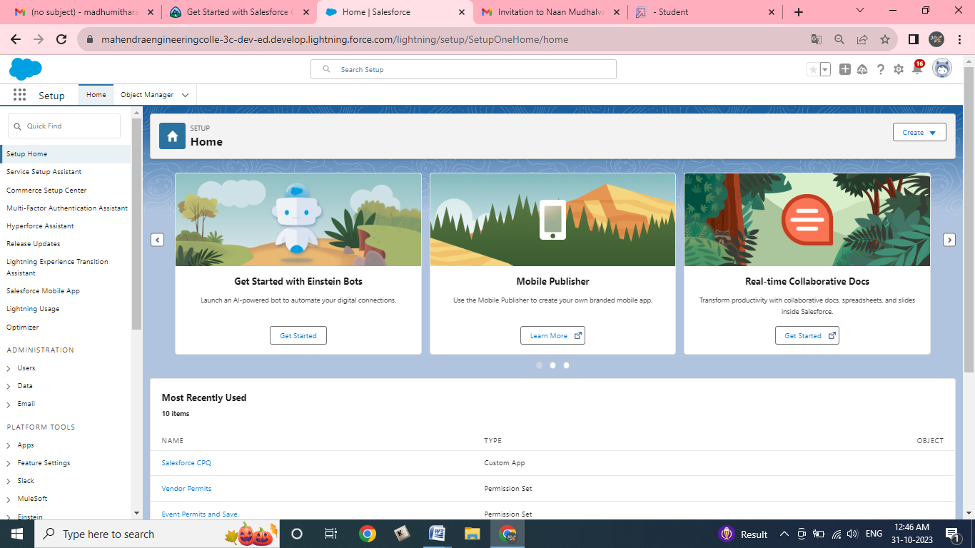

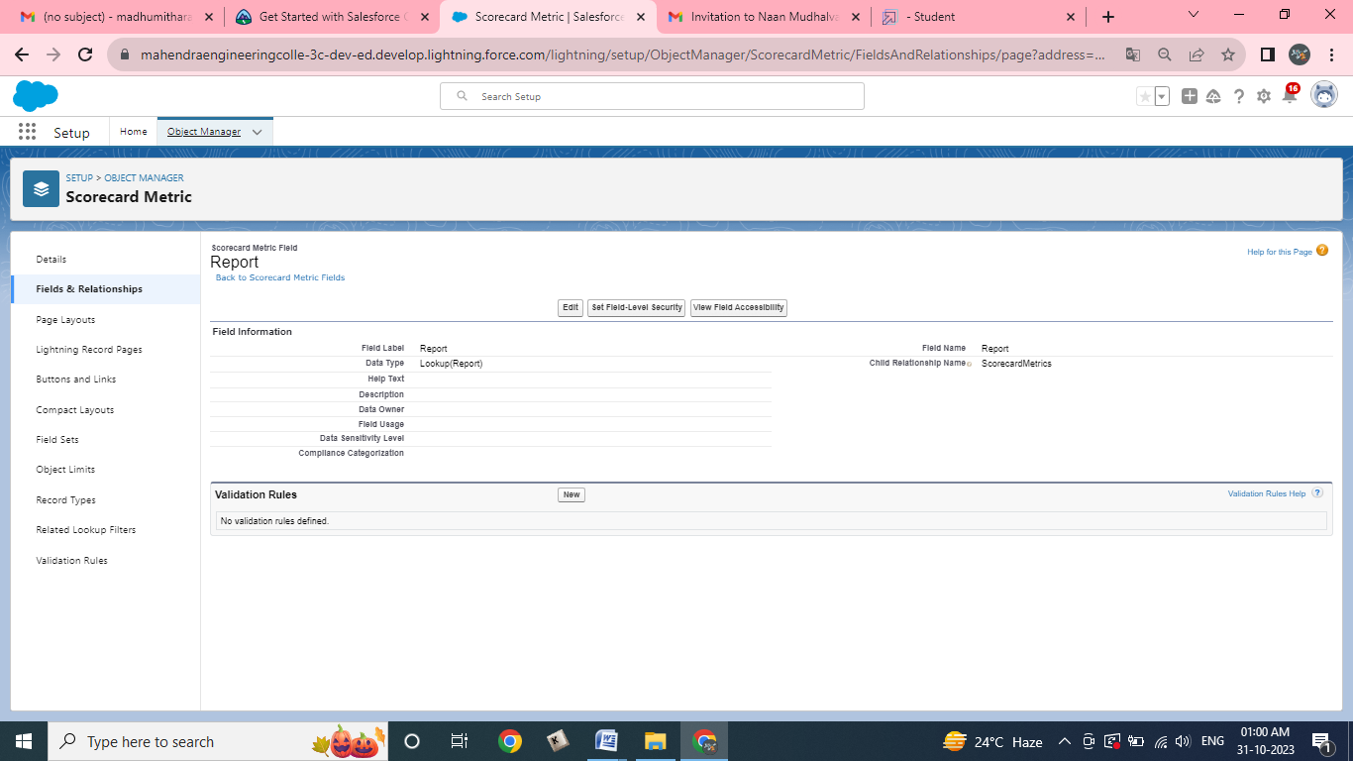

1. Click on Reports Tab.
2. Click on Occasions with Attendees & see records

